**Name: Darshan Soni**

**Batch: TY-CSF 1**

**Roll no: 2213273**

**Assignment 7**

**Aim :** PL/SQL: Implicit and Explicit Cursors and Triggers.

1. Write a Trigger for purchase table where total will be calculated when value is inserted in the table.
2. 1. Use the table prodution.products with Product_id, Product_name, Brand_id, Category_id, model_year,list_price,

2. Declare two variables to hold product name and list price, and a cursor to hold the result of a query that retrieves product name and list price from the production.products table

3. fetch each row from the cursor and print out the product name and list price

**Theory :**

**Cursors:**

A cursor in the context of databases is a database object that enables the traversal of the result set of a SELECT statement. Cursors are primarily used within stored procedures, triggers, and functions to process data row by row. There are two main types of cursors in most database systems:

Implicit Cursors: These cursors are automatically created by the database management system to handle queries inside stored procedures or triggers. Developers do not explicitly declare or manage implicit cursors. They are simple to use but offer limited control.

Explicit Cursors: Developers explicitly declare and manage explicit cursors. They provide more control over the result set traversal. Explicit cursors are typically used when you need to process rows individually, apply conditional logic, or update data row by row within a stored procedure, trigger, or function.

Cursors follow a common pattern:

Declare: Declare the cursor, specifying the SELECT statement that defines the result set to be processed.

Open: Open the cursor to establish the result set.

Fetch: Fetch rows one at a time from the result set into variables for processing. This is typically done within a loop.

Process: Process the fetched row(s) based on your business logic.

Close: Close the cursor when you are done to release resources.

Cursors can be powerful tools for tasks that require row-level operations, but they should be used judiciously as they can lead to performance issues if not used efficiently.

**Triggers:**

Triggers are database objects that are automatically executed when certain events occur within a database. These events include INSERT, UPDATE, DELETE operations on a table. Triggers are often used to enforce business rules, maintain data integrity, and automate tasks such as logging changes or sending notifications.

**Implementations :**

A:

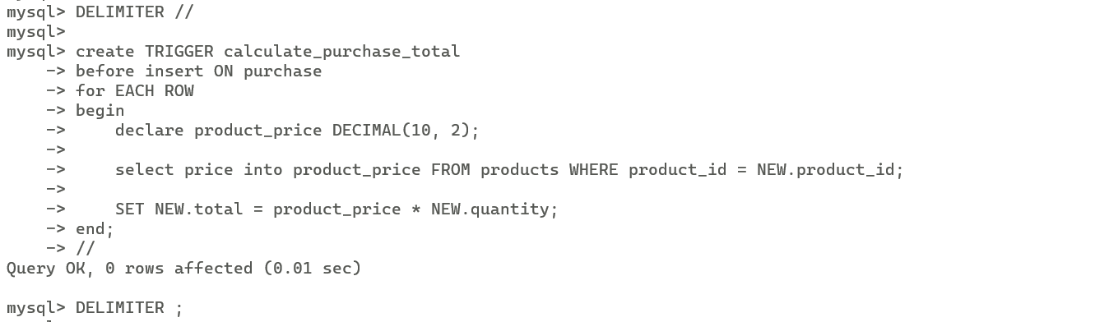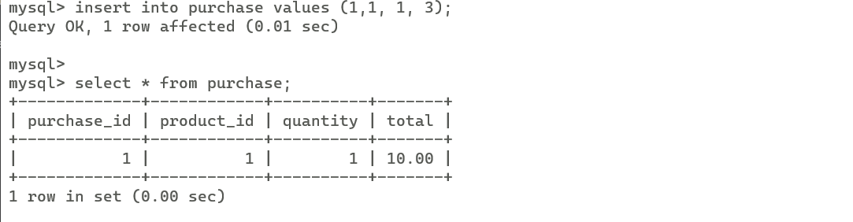

B:



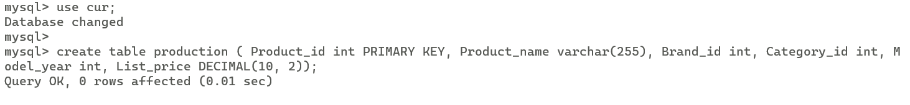



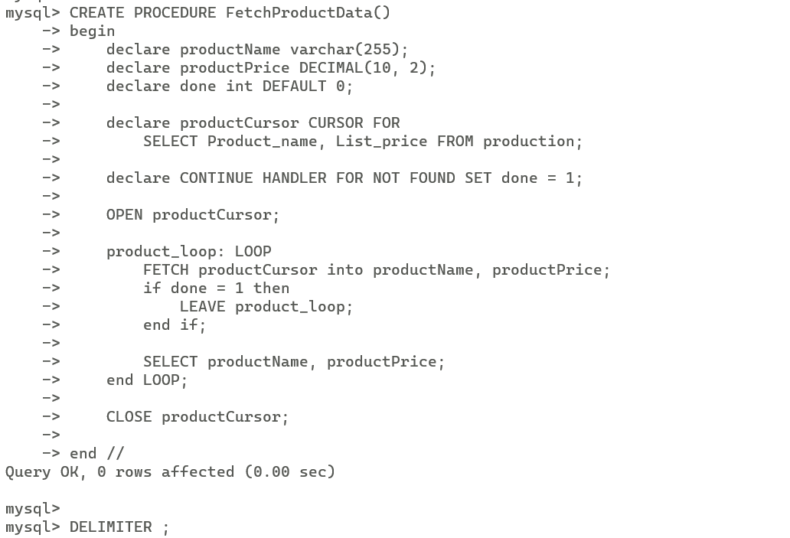

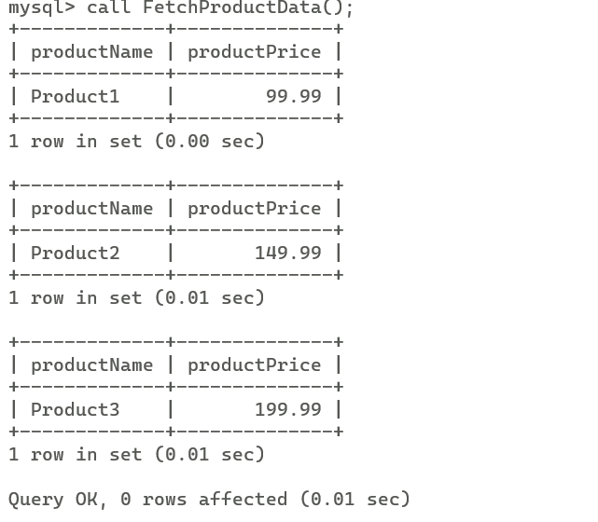

**Conclusion :** PL/SQL concepts such as triggers for automatic total calculation in a purchase table and cursor usage to retrieve and print product details. These practical examples demonstrate how PL/SQL can enhance database functionality, automating calculations and enabling row-level data manipulation for effective data management.